**ONLINE SHOP SYSTEM**

**Report 3 – Software Requirement Specification**

**Developing a building material sales system**

**Version 1.0.1**

**Guided by: Nguyễn Thành Ý**

**Written by: Team2_SE1706**

# Revision History

|  |  |  |  |
| --- | --- | --- | --- |
| **Date** | **Description** | **Author** | **Comments** |
| /01/2023 | Version 1 | Nguyễn Thành Ý | <First Revision> |
| 10/01/2023 | Version 1.1 | Nguyễn Thành Ý |  |
| 16/01/2023 | Version 2 | Nguyễn Thành Ý |  |
|  |  |  |  |

# Document Approval

The following Software Requirements Specification has been accepted and approved by the following:

|  |  |  |  |
| --- | --- | --- | --- |
| **Signature** | **Printed Name** | **Title** | **Date** |
|  | Nguyễn Văn A | Leader |  |
|  | Nguyễn Thành Ý | Instructor, SWP 391 |  |
|  |  |  |  |

# Table of content

Revision History ii

Document Approval ii

Table of content iii

1. Introduction 1

1.1 Overview 1

1.2 Purpose 1

1.3 Scope 1

1.4 Definitions, Acronyms, and Abbreviations 2

2. General Description 2

2.1 Product Perspective 2

2.2 Product Functions 2

2.3 User Characteristics 2

2.4 General Constraints 3

3. Specific Requirements 3

3.1 External Interface Requirements 3

3.1.1 User Interfaces 3

3.1.2 Hardware Interfaces 3

3.1.3 Software Interfaces 3

3.1.4 Communications Interfaces 3

3.2 Functional Requirements 3

3.2.1 System Functional Overview 3

3.2.2 Create customer account 5

3.2.3 <<Feature Name 2>> 6

3.2.3 <<Feature Name 3>> 6

3.3 Use Cases 6

3.2.1 Use Case Overview 7

3.2.2 Use Case Admin 8

3.2.3 Use Case 3 8

3.2.4 Use Case 4 8

3.2.5 Use Case 5 8

3.4 Non-Functional Requirements 8

3.4.1 Performance 8

3.4.2 Availability 9

3.4.3 Security 9

3.5 Inverse Requirements 9

3.6 Design Constraints 9

3.7 Logical Database Requirements 9

3.8 Other Requirements 9

A. Appendices 9

A.1 Business Rule 9

A.2 References 10

I. Introdution.

## 1.1 Purpose

* The project of a sales website with products such as Laptop, Monitor, Mouse, Keyboard,Wheels headset is built with the purpose of providing customers with high quality products. and full of utility features, helping customers easily search, compare, select and purchase necessary products for themselves.
* This document will be used to develop the software requirements specification document, helping to ensure that the software developed meets the product's specification and feature requirements. In addition, the document provides the necessary information to develop new features and enhance the customer experience on this sales site.

## Scope

* The vision of the project is to become one of the leading sales websites in the field of providing professional computer products of the highest quality. With high-quality, diverse and constantly updated products, the website will bring convenience and reliability to customers in shopping and choosing the necessary for their studies and jobs, for their personal purposes. Above all, we hope to provide the basic, comfortable user experience and warranties for user intent that is available to our users.

## Definitions, Acronyms, and Abbreviations

|  |  |
| --- | --- |
| SRS | Software Requirements Specifications |
| BR | Business Rule |
| UI | User Interface |
| N/A | Not applicate, not available |
| User Case(s) | Diagram describe system requirements |

## Bibliography

* IEEE Recommended Practice for Software Requirements Specifications," in IEEE Std 830-1998, vol., no., pp.1-40, 20 Oct. 1998.
* IEEE Guide for Developing System Requirements Specifications," in IEEE Std 1233-1996, vol., no., pp.1-30, 22 Dec. 1996.
* Custom Software Requirements Specification Document Example (International Standard) - Software Development Company.

## General

* This document is written in accordance with the Software Requirements Specifications (SRS) described in the "IEEE Recommended Practice for Software Requirements Specifications" and the "IEEE Guide for Developing System Requirements Specifications".
* With the structure divided into three parts:

1. Part 1: Provides an overview of the components of SRS.

2. Part 2: An overview of the factors, constraints, user characteristics, execution environment that impact the system and its requirements. Provides detailed information on functional requirements, providing software developers with information to develop software that meets those requirements.

3. Part 3: Non-functional requirements.

# General Description

## Product Perspective

* The system consists of Guest, Customer and Adminitrator agents.
* Guest is a user who is not logged in to the system.
* Customer has the role of customer the operation of the system.
* Adminitrator has the role of administering the operation of the system.

## Product Functions

1. Login: this function is designed to offer system access privileges and scope by autherticating user vefore they interact with the system.
2. Regisster: about save user data and notify user to discounts.
3. User adminitraction: the adminitraction is responsible for managing the system’s user.
4. Product management functional groups : to help administrators with product buying and selling.
5. Purchase insurance: user is utilice the capability to purchase insurance so they may profit if they run into issues.

## Agents

* The system consists of agents who are Guest, Customer and Administrator.
* Guest: This is a user who visits the website and performs activities on the website, but has not registered for an account. Customers can view product information, prices and policies of the online store. The role of the customer is to consult and learn about products and services before deciding to buy.
* Customer: This is a user who has registered an account on the website and can log in to use the website's functions such as placing orders, viewing order history, managing personal information and registering to receive news. instant, promotion from online store. The customer's role is to be the consumer of the online store's products and services. Customers can bring the product to warranty when the product has a fault
* Administrator: This is the person who manages and runs the entire operation of the online store, including tasks such as product management, order management, customer information management, Store activity statistics. The administrator's role is to ensure that the operations of the online store are carried out efficiently, that the customer needs are met, and that the store's business goals are achieved. Will evaluate the product when the product is brought to the warranty beyond the specified.

**COMPUTER PROJECT**

## The functions of the system

* Guest: Customers have the right to view product and service information of the online store, place orders and pay for their orders. Customers are also responsible for providing secure that their personal and payment information.
* User: Customer has the right to register and log in to an account, view order history, manage personal information, perform activities on the website such as placing orders, discussing with customer support staff and product reviews. The customer is also responsible for performing activities on the website in accordance with the regulations of the online store. Customers buy products with warranty cards and bring the products for warranty when they encounter errors.
* Administrator: Administrator has access to and manages the entire operation of the online store, including product management, orders, customer information, and store activity reporting statistics. row. The administrator is also responsible for administering the operation of the online store to be carried out in accordance with regulations, protecting the personal information and customer orders. The administrator also has the right to delete the product when the error is reported beyond the specified limit.

## Assumptions and Dependencies

* The user should have fufficient knowledge about computers
* The computer should have an internet connection and buternet server capabilities
* The user know the English language, as the interface with be provided in English

# Specific Requirements

## External Interface Requirements

### User Interfaces

* Ul-1: The website header will include the website's logo, address, phone number, and main categories: The middle of the page displays the products, the bottom of the page is divided into newsgroups (warranty policy, promotions.
* Ul-2: The interface is suitable for display on computers and phones
* U-3: Use icons to provide more detail to users.
* U-4: The main color of the website is red, white one, and sometimes black

### Hardware Interfaces

* No hardware interfaces have been identified

### Software Interfaces

* The website does not integrate other commercial software

### Communications Interfaces

* The web browser will entomatically log out if the user does not use the system within 10

## 3.2 Functional Requirements

This section describes specific features of the software project. If desired, some requirements may be specified in the use-case format and listed in the Use Cases Section.

### 3.2.1 System Functional Overview

#### System Functional Overview will describe the most overview of the functionality of the website, detailing each function and requirements of the screen flow, screen descriptions, system user roles, screen authorization, non-screen functions, ERD

#### 3.2.1.1 Screens Flow

#### 3.2.1.2 Screen Descriptions

*[Provide the descriptions for the screens in the Screens Flow above]*

|  |  |  |  |
| --- | --- | --- | --- |
| **#** | **Feature** | **Screen** | **Description** |
| 1 | Order Meals | Create Order | <<Screen Brief description>> |
| 2 | Order Meals | Change Order |  |
| 3 | .. |  |  |

#### 3.2.1.3 Screen Authorization

|  |  |  |  |  |
| --- | --- | --- | --- | --- |
| **Screen** | **Admin** | **Employee** | **Customer** | **Guest** |
| **Home Page** | X | X | X | X |
| **Product List** | X | X | X | X |
| **Product Details** | X | X | X | X |
| **Active/Deactive an Employee** | X |  |  |  |
| **View his/her orders** |  |  | X |  |
| **Employee Edit** | X | X |  |  |
| **News List** | X | X | X | X |
| **Add News** | X | X |  |  |
| **News Details** | X | X | X | X |
| **Edit News information** | X | X |  |  |
| **Edit User** | X | X |  |  |
| **Delete User** | X | X |  |  |
| **Order List** | X | X |  |  |
| **Order Details** | X | X |  |  |
| **Guarantee List** | X | X |  |  |
| **Create Guarantee** | X | X |  |  |
| **Edit Guarantee** | X | X |  |  |
| **Delete Guarantee** | X | X |  |  |
| **Forgot Password** | X | X | X | X |
| **Change Password** | X | X | X | X |
| **User Profile** | X | X | X |  |
| **Accounts List** | X |  |  |  |
| **Account Details** | X |  |  |  |
| **Customers List** |  | X |  |  |
| **Customers Details** |  | X |  |  |
| **Settings List** | X |  |  |  |
| **Setting Details** | X |  |  |  |

#### 3.2.1.4 Non-Screen Functions

|  |  |  |  |
| --- | --- | --- | --- |
| **#** | **Feature** | **System Function** | **Description** |
| 1 | <<Feature Name>> | <<Function Name1>> | <<Function Name1 Description>> |
| 2 | … |  |  |

#### 3.2.1.5 Entity Relationship Diagram

*[Provide the entity relationship diagram and the entity descriptions in the table format as below]*

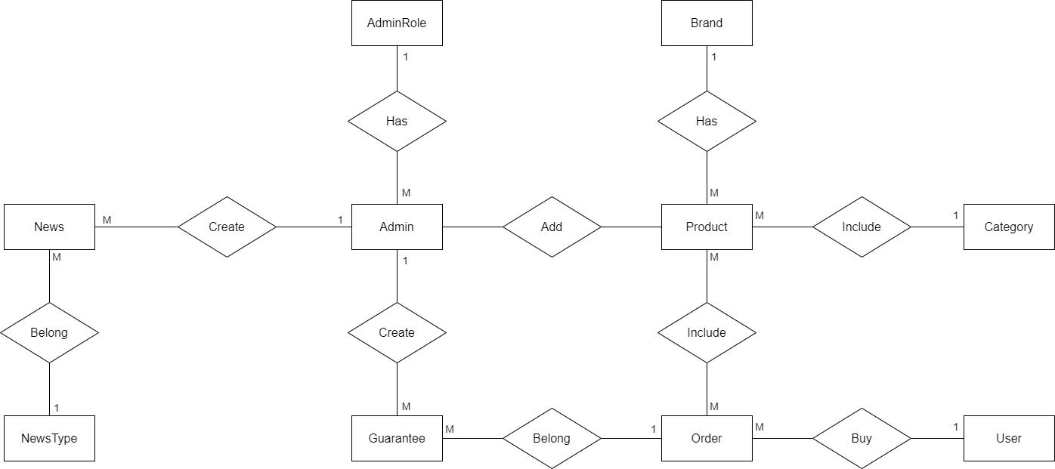

## User Case Overview

**Figure 2-1: Overview use case chart**

### User Case Admin

**Figure 2-2: Administrator use case chart**

### User Case Customer

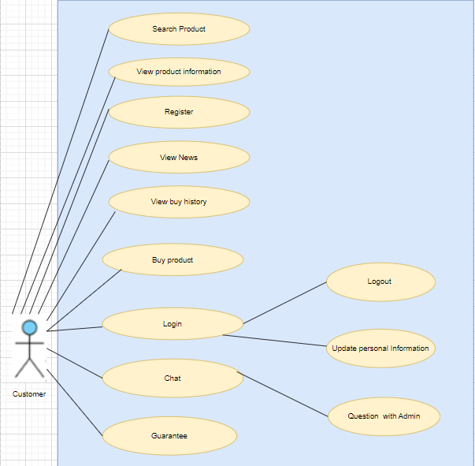

**Figure 2-2: Customer use case chart**

### User Case Guest

**Figure 2-3: Guest use case chart**

## Function Requirement

### Create account

|  |  |
| --- | --- |
| Name | Login, Logout, Sign up, Change Password |
| Created By | Vinhnq |
| Date Created | 18-5-2023 |
| Primary Actor | Admin |
| Trigger | Actor clicks login, logout user account, add, change user account on database |
| Desconditions | User account & clicks button login, logout, sign up, change password account |
| Postconditions | Login user account join page, logout user account, Create a new user account can be active, Change |
| Normal Flow | + Login  1. Enter account and password in login screen to log in  2. Software: Display Management screen  + Logout  Click button logout  + Add user account  1. click on "sign up " button  2. Software Display add account screen: Information of account +"sign up" button  3. Fill in all information account and click on  4 . Software: Check duplicated then update to database  5. if not duplicated add new user for database  + Change password  1. click on "change password " button  2. Software Display change account screen: Old password of account +"change" button  3. Fill old password and new password  4. Update new password for database |
| Alternative Flows | N/A |

### Blogs management of Admin

|  |  |
| --- | --- |
| **Name** | **Create Blog Post, Read Blog Post, Update Blog Post, Delete Blog Post** |
| Created By | SonTD |
| Date Created | 21-5-2023 |
| Primary Actor | User |
| Trigger | Actor clicks create, read, update, or delete blog post buttons |
| Preconditions | **Blog Creation and Publishing**  Registered users shall be able to create new blog posts. The system shall provide a rich text editor or a markdown editor to allow users to format and structure their blog posts. Users shall be able to add images, videos, and other media to their blog posts. Users shall have the ability to save drafts of their blog posts and publish them when ready.  **Blog Management**  Users shall be able to edit and update their published blog posts. Users shall have the ability to delete their blog posts. The system shall support categorization and tagging of blog posts for easy navigation and search.  **Blog Interactions**  Users shall be able to read and view published blog posts. The system shall provide options to like and comment on blog posts. Users shall be able to share blog posts on various social media platforms. The system shall display related or recommended blog posts based on user preferences and content similarity. **Search and Discovery**  The system shall provide a search functionality to allow users to search for specific blog posts, topics, or users. The system shall support advanced search filters, such as date range, category, and popularity. The system shall provide recommendations and suggestions based on user preferences and browsing history. |
| Postconditions | Blog post is successfully created, read, updated, or deleted |

### Staff management of Admin

|  |  |
| --- | --- |
| Name | **Create Staff Account, Read Staff Account List, Update Staff Account, Delete Staff Account, Undo Staff Account, Read Deleted Staff Account List, Delete Checked Staff Account, Undo Checked Staff Account, Delete All Staff Accounts, Undo All Staff Accounts** |
| Created By | Tanpqn |
| Date Created | 24-5-2023 |
| Primary Actor | Admin |
| Trigger | Actor clicks create, read, update, or delete staff account |
| Desconditions | User is on the platform and clicks the respective buttons |
| Postconditions | User can successfully create, read, update, or delete staff accounts |
| Normal Flow | + Read List Staff Account  1. Click on "Quản lý nhân viên" button in side bar to access to staff accounts list page  2. Software: Display all staff accounts  + Create Staff Account  1. Click on " Thêm tài khoản nhân viên " button  2. Software Display add account screen: Information of account +"Lưu lại" button +"Hủy bỏ" button  3. Fill in all information account and click on "Lưu lại" button  4. Software: Check all information cell is valid and not empty  5. If all information cell is valid the account will be created in database  6. If all information cell is invalid or empty the system will announce user  7.If click on "Hủy bỏ" button, the action create account will be removed and return to show account list page  + Update Staff Account  1. Click on " edit" button  2. Software Display update account screen: Information of account +"Lưu lại" button +"Hủy bỏ" button  3. Fill in all information account and click on "Lưu lại" button  4. Software: Check all information cell is valid and not empty  5. If all information cell is valid the account will be updated in database  6. If all information cell is invalid or empty the system will announce user  7. If click on "Hủy bỏ" button, the action update account will be removed and return to show account list page  + Delete Staff Account  1. Click on "trash" button  2. The system will alert the user want to delete this account  3. If click on "Đồng ý" button the account will be deleted and added to deleted staff accounts list  4. If click on "Hủy bỏ" button, the action delete account will be removed  + Read Deleted Staff Account List  1. Click on "Danh sách tài khoản nhân viên đã xóa" button in staff accounts list page to access to deleted staff accounts list page  2. Software: Display all to deleted staff accounts list  + Undo Staff Account  1. Click on "undo" button in deleted staff accounts list page  2. The system will alert the user want to undo this account  3. If click on "Đồng ý" button the account will be undid and added to staff accounts list  4. If click on "Hủy bỏ" button, the action undo account will be removed  + Delete Checked Staff Account  1. Click on check box in "Tick để xóa" column to choose accounts user want to delete.  2. Click on "Xóa đã chọn" button to delete all chosen staff accounts and those accounts will be added to deleted staff accounts list.  + Delete All Staff Accounts  1. Click on "Xóa tất cả" button  2. All accounts in staff accounts list page will be deleted and added to deleted staff accounts  + Undo Checked Staff Account  1. Click on check box in "Tick để hoàn tác" column to choose accounts user want to undo.  2. Click on "Hoàn tác đã chọn" button to undo all chosen staff accounts and those accounts will be added to staff accounts list.  + Undo All Staff Accounts  1. Click on "hoàn tác tất cả" button  2. All accounts in staff accounts list page will be undid and added to staff accounts |
| Alternative Flows | N/A |

### Order management

|  |  |
| --- | --- |
| Name | **Read Order List, Cancel Order, Accept Order, Read Detail Order** |
| Created By | Tanpqn |
| Date Created | 24-5-2023 |
| Primary Actor | Admin |
| Trigger | Actor clicks read, accept, or cancel order |
| Desconditions | User is on the platform and clicks the respective buttons |
| Postconditions | User can successfully read, accept, or cancel order |
| Normal Flow | + Read Order List  1. Click on "Quản lý đơn hàng" button in side bar to access to order list page  2. Software display order list  + Cancel Order  1. Click on "trash" button in "Chức năng" column  2. The system will alert the user want to cancel this order  3. If click on "Đồng ý" button the order will be cancelled and the status will be update to "Đã hủy"  4. If click on "Hủy bỏ" button, the action cancel order will be removed  + Accept Order  1. Click on "check" button in "Chức năng" column  2. The order will be accepted and the status will be update to "Đang vận chuyển"  + Read Detail Order  1. Click on "eye" button in "Chức năng" column to access to detail order page  2. System will show all details about order |
| Alternative Flows | N/A |

### User management on Admin

|  |  |
| --- | --- |
| Name | **Read User List, Cancel User, Accept User, Update User** |
| Created By | Hadt |
| Date Created | 25-5-2023 |
| Primary Actor | Admin |
| Trigger | Actor clicks read, accept, or cancel user |
| Desconditions | User is on the platform and clicks the respective buttons |
| Postconditions | User can successfully read, accept, or cancel user |
| Normal Flow | + Read User List  1. Click on "Quản lý người dùng" button in side bar to access to user list page  2. Software display user list  + Cancel User  1. Click on "trash" button in "Chức năng" column  2. The system will alert the admin want to cancel this user  3. If click on "Đồng ý" button the user will be cancelled and the status will be update to "Đã hủy"  4. If click on "Hủy bỏ" button, the action cancel user will be removed  + Accept user  1. Admin want delete multiple users, click checkbox to delete multiple user |
| Alternative Flows | N/A |

### Product management on Admin

|  |  |
| --- | --- |
| Name | **Read product List, Cancel product, Accept Product, Update Product** |
| Created By | Dattt |
| Date Created | 25-5-2023 |
| Primary Actor | Admin |
| Trigger | Actor clicks read, accept, or cancel product |
| Desconditions | User is on the platform and clicks the respective buttons |
| Postconditions | User can successfully read, accept, or cancel product |
| Normal Flow | + Read product List  1. Click on "Quản lý sản phẩm" button in side bar to access to product list page  2. Software display product list  + Cancel product  1. Click on "trash" button in "Chức năng" column  2. The system will alert the admin want to cancel this product.  3. If click on "Đồng ý" button the user will be cancelled and the status will be update to "Đã hủy"  4. If click on "Hủy bỏ" button, the action cancel product will be removed  + Accept product  1. Admin want delete multiple product, click checkbox to delete multiple product.  2 . Admin want edit product, click “Chức năng” button “Edit” to edit product. |
| Alternative Flows | N/A |

### Guarantee management on Admin

|  |  |
| --- | --- |
| Name | **Read product on guarantee List, Cancel product on guarantee , Accept product on guarantee** |
| Created By | VinhNq |
| Date Created | 25-5-2023 |
| Primary Actor | Admin |
| Trigger | Actor clicks read, accept, or cancel product on guarantee. |
| Desconditions | User is on the platform and clicks the respective buttons |
| Postconditions | User can successfully read, accept, or cancel product on guarantee |
| Normal Flow | + Read product List  1. Click on "Quản lý bảo hành" button in side bar to access to product on guarantee list page  2. Software display product on guarantee list  + Cancel product on guarantee  1. Click on "trash" button in "Chức năng" column  2. The system will alert the admin want to cancel this product.  3. If click on "Đồng ý" button the user will be cancelled and the status will be update to "Đã hủy"  4. If click on "Hủy bỏ" button, the action cancel product will be removed  + Accept product  1. Admin want delete multiple product, click checkbox to delete multiple product.  2 . Admin want edit product, click “Chức năng” button “Edit” to edit product. |
| Alternative Flows | N/A |

# Non-functional Requirements

## Usability

The web application shall have an intuitive and user-friendly interface.  
The system shall provide clear and informative error messages to guide users in case of invalid inputs or errors.  
The system shall be responsive and compatible with a variety of devices and screen sizes.

## Performance

The system shall be able to handle a large number of concurrent users without significant degradation in performance.  
Blog posts and user profiles shall load quickly, providing a seamless browsing experience.  
The system shall implement caching mechanisms to improve performance and reduce server load.

## Secutity

User passwords shall be securely stored using industry-standard hashing algorithms.  
 The system shall implement measures to prevent unauthorized access, such as secure session management and authentication mechanisms.  
The system shall protect against common web vulnerabilities, including cross-site scripting (XSS) and SQL injection attacks.User passwords shall be securely stored using industry-standard hashing algorithms.

## Scalability

The system architecture shall be designed to allow for horizontal scalability to accommodate increasing user traffic and data growth.  
The system shall support efficient database indexing and optimization techniques to handle large amounts of data.

## 4.5 Availability

The system shall have a high level of availability, with minimal downtime for maintenance or upgrades.  
The system shall implement backup and disaster recovery mechanisms to ensure data integrity and availability.  
Software Requirements Specification (SRS) for Blogs Application Web

# Change Management Process

# Appendices

## A.1 Business Rule

## BR-01 Full name must be 8-32 chẩcters amd contains uppercase, lowercase, numbers and special characters.

## BR-02 Each user has exactly one role

## BR-03 Email must be in the correct format [abc@gmail.com](mailto:abc@gmail.com)

## BR-04 The structure needs to be SEO standard

## BR-05 Each user must have explicit permissions

## BR-06 The password entered must have enough numbers, uppercase, lowercase letters and special characters

## BR-07 Phone number must be 10 digits